**National University of Computer & Emerging Sciences (NUCES) Islamabad,**

Department of Computer Science

**Programming Fundamentals – Fall 2022**

**LAB 08**

|  |
| --- |
|  |
|  |  |



**Learning Outcomes**

In this lab you are expected to learn the following:

* Loops (while0

**While Loop**

In computer programming, loops are used to repeat a block of code.

For example, let's say we want to show a message 100 times. Then instead of writing the print statement 100 times, we can use a loop.

That was just a simple example; we can achieve much more efficiency and sophistication in our programs by making effective use of loops.

The syntax of the while loop is:

while (condition)

{ // body of the loop }

Here,

* A while loop evaluates the condition
* If the condition evaluates to true, the code inside the while loop is executed.
* The condition is evaluated again.
* This process continues until the condition is false.
* When the condition evaluates to false, the loop terminates.

For example:

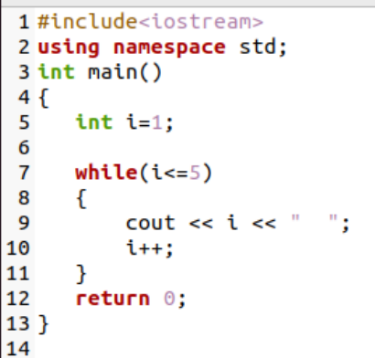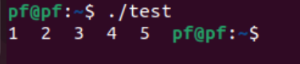

**Task 1:**

Write a program that asks the user to type 10 integers. The program then computes how many even and odd numbers were entered using.

**Task 2:**

Write a C++ program that asks user to enter two numbers: the number and limit then print table of the number until the specified limit.

If number=2 and limit=3

2*1=1

2*2=4

2*3=6

Place a check on both inputs (number, and limit) to be positive values, in case of negative values the program must display a proper message of exiting.

**Task 3:**

Write a C++ program that generates Fibonacci sequence. The program must input a number and your program must display the Fibonacci sequence to that certain number. If the input is 10, then the output must be the first 10 numbers of the Fibonacci series. Additionally, the program checks that the user enters number greater than 2.

**Task 4:**

Write a program that enter a number from user and display its factorial. e.g. factorial of 5 is

1 X 2 X 3 X 4 X 5=120. Where is N<=20.

**Task 5:**

Write a program in C++ to find the Greatest Common Divisor (GCD) of two numbers using while loop.

Sample Output:

Input the first number: 25

Input the second number: 15

The Greatest Common Divisor is: 5